Case Study on Performance System – Fossil Group

# The Evolution of Fossil's Performance Management Process

Fossil Group was using a complex, 100% paper process for performance reviews and check-ins for more than 15,000 global employees. They wanted to move toward a digital performance management strategy, but knew they needed to simplify the process first.

Fossil Group set up four traditional components that were stretched across three strategic touch points throughout the year. These touch points were supplemented with ongoing performance conversations that could be initiated by any employee, at any time.

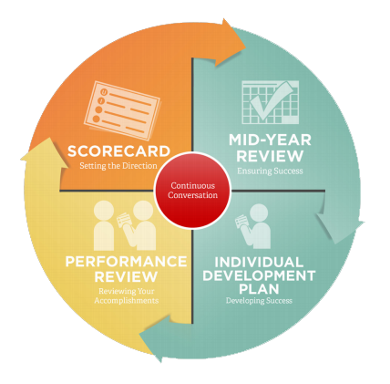

As Fossil Group evolved its company-wide performance approach, they were happy to see immediate progress.

92% of employees were participating in goal-setting reviews, setting an average of six goals per employee.

However, when they dug into the data, they found that 35% of individual goals created were misaligned or did not have an impact on the organization and its strategic priorities. They knew they needed to get better at goal alignment if they wanted to meet important business objectives.

Explore the three ways Fossil Group simplified performance management.

## 1. They scheduled ongoing performance conversations and continuous feedback.

Although the three formal performance touch points in place were working, Fossil Group knew teams needed to have goal conversations more frequently. They implemented informal “check-ins” that could be launched by any employee at any time.

To ensure adequate time was made for important performance conversations and other performance related activities, Fossil Group implemented "Performance Days" — days strictly dedicated to employee performance. On these days, no task-related meetings are scheduled, and all work is set aside for the day. Conversations between managers, employees, and teams are all centered on performance.

## 2. They created intuitive goal conversation templates.

Fossil Group recognized that simply having more performance conversations wasn’t enough — the conversations needed to include healthy dialogue, debate, and collaboration from managers and employees. They created 1-on-1 templates to help guide managers and employees through an effective and productive goal conversation.

Check-in templates could be customized to the needs and work of individual teams and team members. The templates helped ensure conversations were focused on creating clear, aligned, and motivating goals.

## 3. They used recognition to keep performance conversations fresh.

Fossil Group wanted to bring performance conversations full circle by recognizing employee performance daily. They created recognition toolkits for managers including fun notecards, gift cards, and employee recognition tips. They also launched an online, peer-to-peer recognition program that generated an average of 140 recognition stories each week.

By taking time to uncover the needs of its employees, and delegating time for managers to focus on performance, Fossil Group was able to listen and act on employee voices and evolve their performance strategy for success.